Installing Python 2.7 manually
- Download Python2.7 installer from https://www.python.org/downloads/release/python-2718/
- Run and install in suitable directory like c:\development\Python27
- Choose “Add Python.exe to the Path” in the “Customize Python 2.7.18” by selecting “Will be installed on the local hard drive”; Skip the next step
- Add c:\development\Python27\ to the Path environment variable.
- To do so search “Edit the system variables” and click on the “Environment Variables …” button, click on the line for the “Path” environment variable in the “System variables” section. Click on “new” button and type the directory of your python folder. Move it up until it appears above the one for “WindowsApps”. Click ok when done.
- Repeat for c:\development\Python27\Scripts
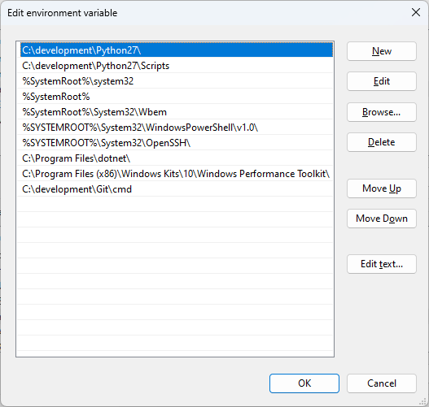

- Open a command prompt (“cmd”) and type “python”, you should see
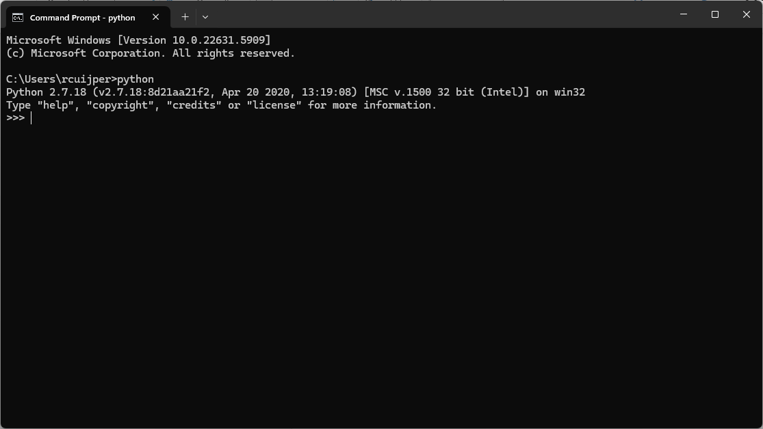
- Type exit() or CTRL-z to close.
Note:
If you also have python 3 installed, you can access it using “py”, “py3”, or “python3”
When using pip make sure that you are using the right version of python on your system. For example, python -m pip install numpy. Verify versions using python –version or pip –version. When using Visual Studio Code, make sure it is pointing to the right python version on your system.

Installing packages

Installing Python Packages
In the manual version packages are not installed automatically. Luckily Python made this easy:
Open the regular command shell by typing CMD in the search option
In the opened command shell type: python -m pip install package_name ( or py -m install on newer python distributions on windows)
For example, to install numpy, scipy and matplotlib:
pip install numpy scipy matplotlib
- On windows it is common to precede the pip command by python -m, e.g.:
python -m pip install numpy scipy matplotlib (newer windows distributions use py instead of python)
- It is always a good idea to check the version of your python distribution, e.g.:
python –version ( or py –version on windows) might point to python 2.x or python 3.x depending on your installation process.
Optionally add opencv (we need the latest version that supports python 2.7):
pip install opencv-python==4.2.0.32

Installing naoqi SDK for Python
To be able to communicate with the simulated (or real) NAO robot, you need to have the Python SDK of naoqi (the OS of the NAO robot). There used to be an installer, but it assumes a system wide installation of python 2.7, which is usually not the case.
- Download “pynaoqi-python2.7-2.5.7.1-win32-vs2013.zip”
- Extract in a suitable folder e.g. c:\development\
- Make naoqi library findable for Python. There are many ways:
  - Deprecated Adding the path tot the PYTHONPATH environment variable. Not recommended if you have multiple python versions. See installing python above for how to add environment variables. You will need to restart python and your command shell to make this work.
  - Add to sys.path inside of your own script:
import sys
sys.path.append(r“c:\development\pynaoqi-python2.7-2.5.7.1-win32-vs2013\lib”)
Note that you need to either escape the backslash character by using \\ or use a raw string by preceding it with r. Using slash also works.
Note that at the end it says “\lib”. Don’t forget!
  - Create a naoqi.pth file inside the site-packges directory of your python distribution
    - Find the site-packages directory in your python distribution e.g. c:\development\Python27\lib\site-packages
    - Create a file called naoqi.pth containing only the path to your pynaoqi library:
c:\\development\\pynaoqi-python2.7-2.5.7.1-win32-vs2013\\lib
Method b is most flexible, method c is more permanent
- Check your installation by opening IDLE (Python GUI) and check you are running the right python version. Then type:
>>> import naoqi
If this gives no error, the naoqi SDK is installed correctly. If it does give an error, it usually means the pathname is not added correctly

